**1st Grade Social Studies At a Glance**

|  |  |  |
| --- | --- | --- |
| **Grading Periods** | **Unit Name** | **Estimated Timeframe** |
| **1st Grading Period** | **Unit: At School** | 25 days |
| • **My School, My Community – Chapter 1** o I Am a Good Citizen – 3 days  ▪ Traits of good citizens   * My Rights and Responsibilities – 4 days   + Home and school * I Follow Rules and Laws – 3 days   + Home and school * My Leaders – 4 days   + Home, school, community * My Government – 3 days   + Community, state, nation * Locations in the School – 4 days   + Classroom, office, nurse, gym,   cafeteria   * Symbols of My Country – 5 days   + Flag, eagle, rose, White House, Star Spangled Banner and Francis Scott   Key, pledge of allegiance, Statue of Liberty |  |
| **Unit: Holidays and Celebrations (taught when holiday falls)** | 3-5 days per |
| * **Labor Day** o Purpose of and when established   + How celebrated * **Texas First Responders Day (September 11th) 2 Days** o Honors those who assist in emergencies * **Constitution Day (Sept 17th)and Celebrate Freedom**   **Week** o What document means? o Who signed and why?   * + Symbols that represent freedom in our country * **County Fair Day** o Why important to local community? |  |
| **2nd Grading Period** | **Unit: Everyone Works** | 25 days |
| • **Work in the Community –Chapter 2**   * Needs and Wants – 4 days   + Basic Human Needs * Goods, services, and products – 4 days ▪ Examples from home, school, and community   + How exchanged and role of markets * Why we Make Choices – 3 days   + Choices people make impact of wanting more than they can have * Buying and Selling – 5 days   + Role of markets and how people exchange items within * Spending and Saving – 5 days   + Why we save and how we spend money * Jobs People Do – 5 days   + Specialized jobs and how they contribute to goods and services |  |
| **Unit: Geography: Map Skills and Human Characteristics** | 20 days |
| **Looking at Our World – Chapter 3**  • Where Things are Located – 4 days o map skills |  |

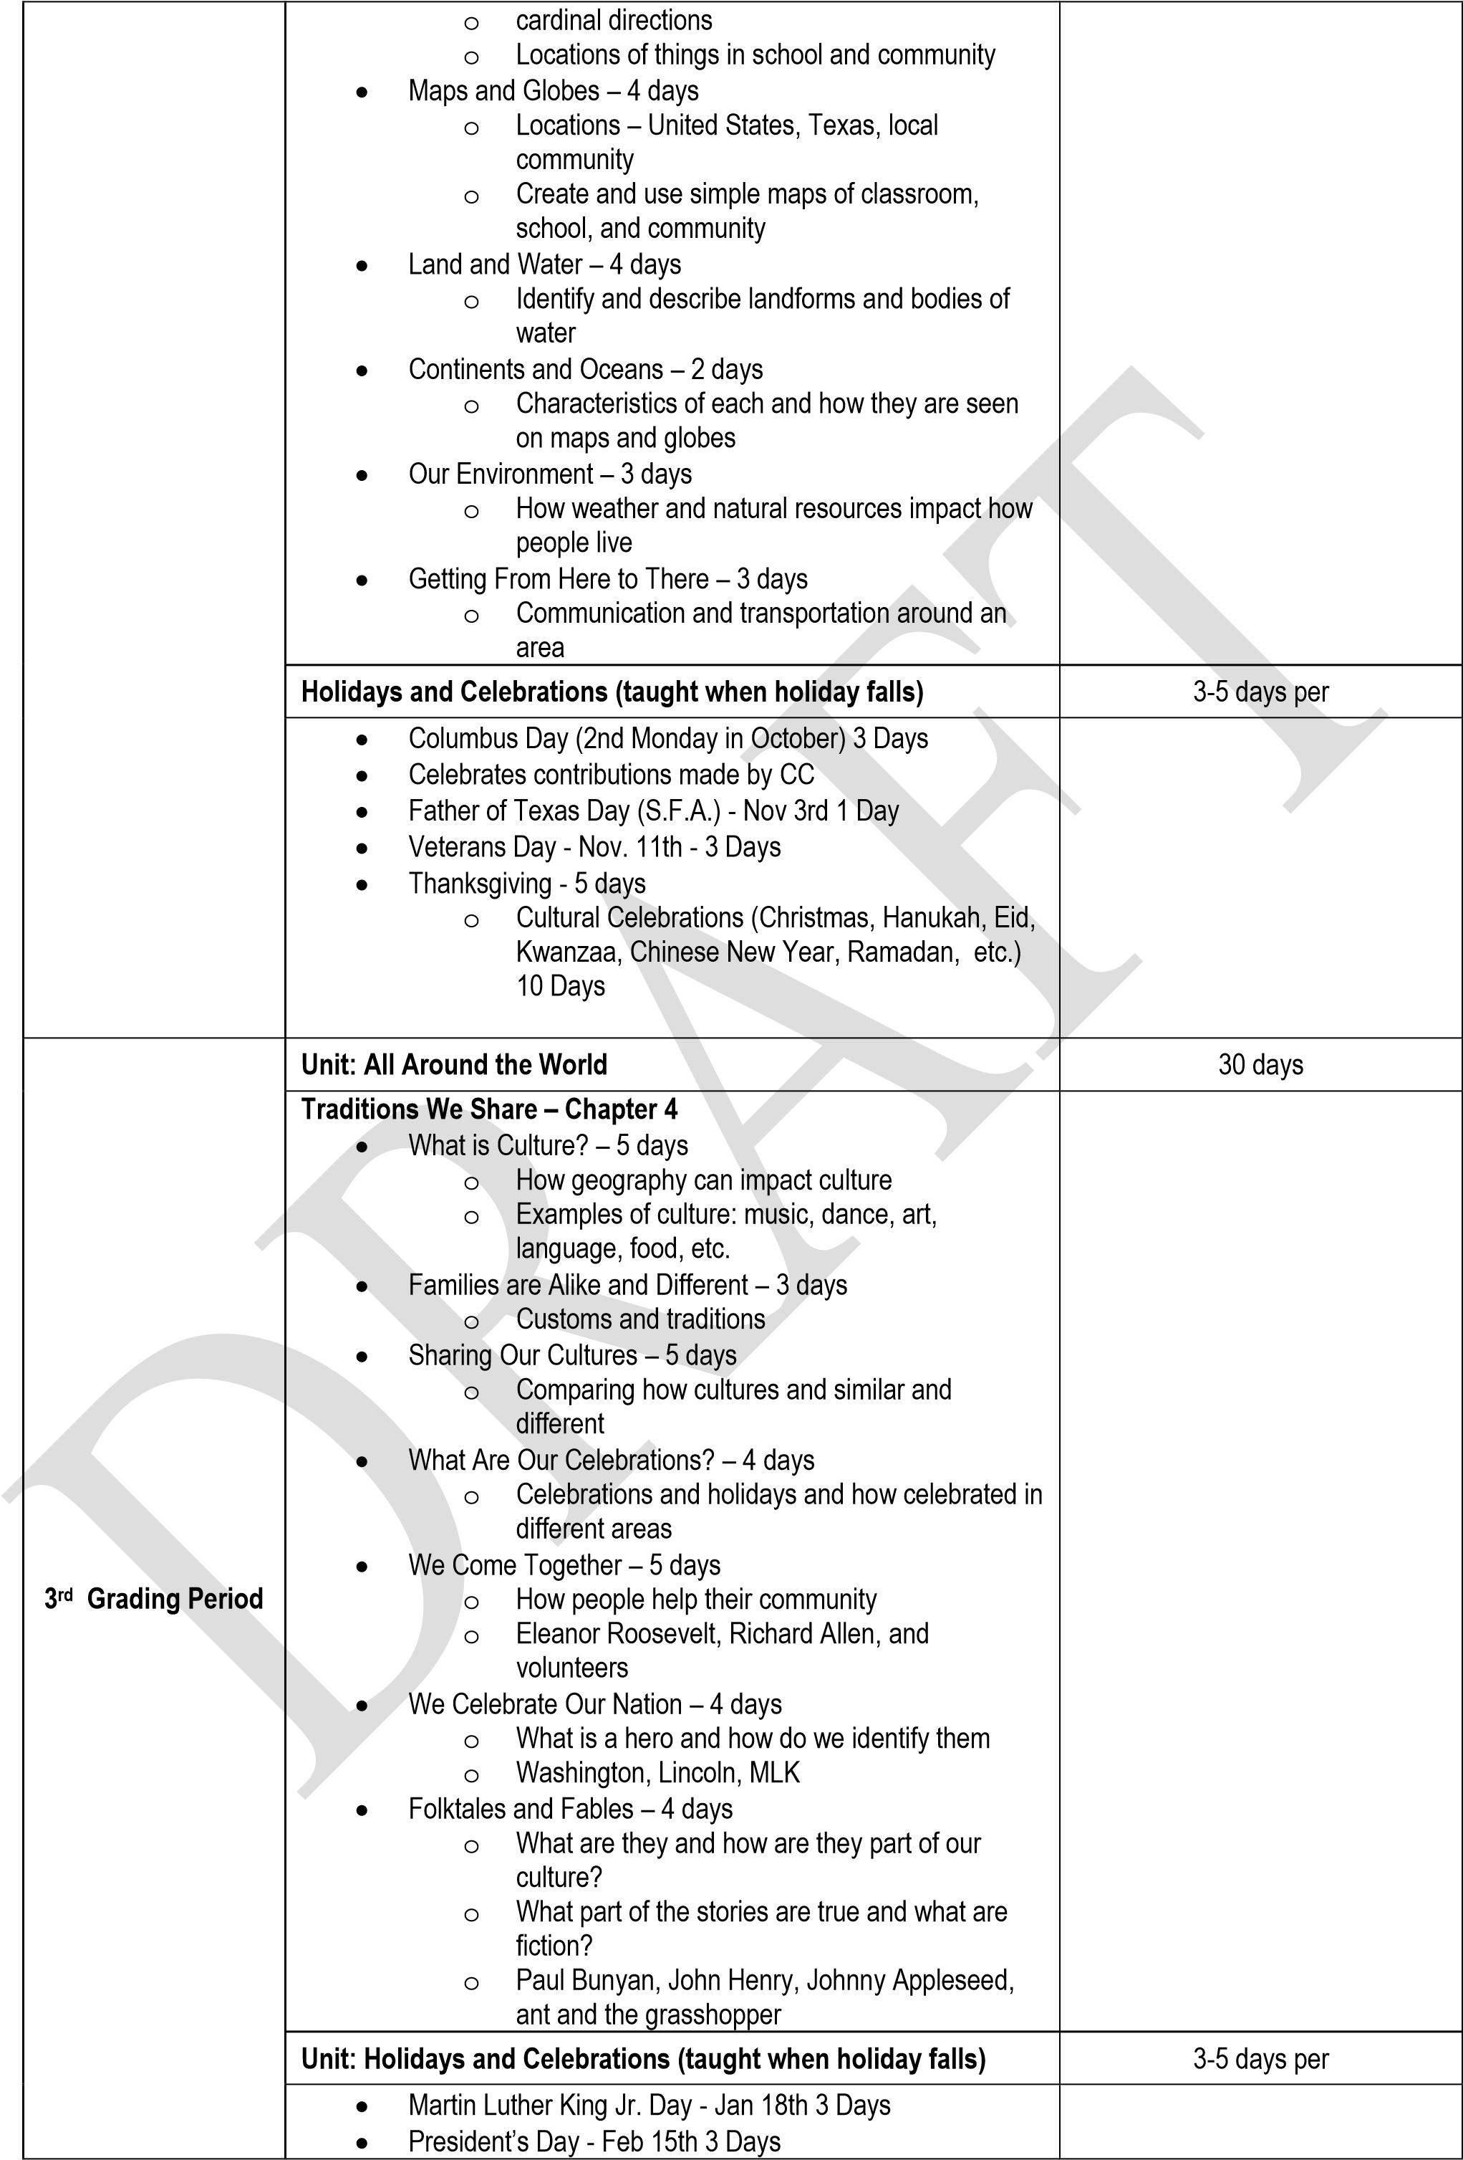

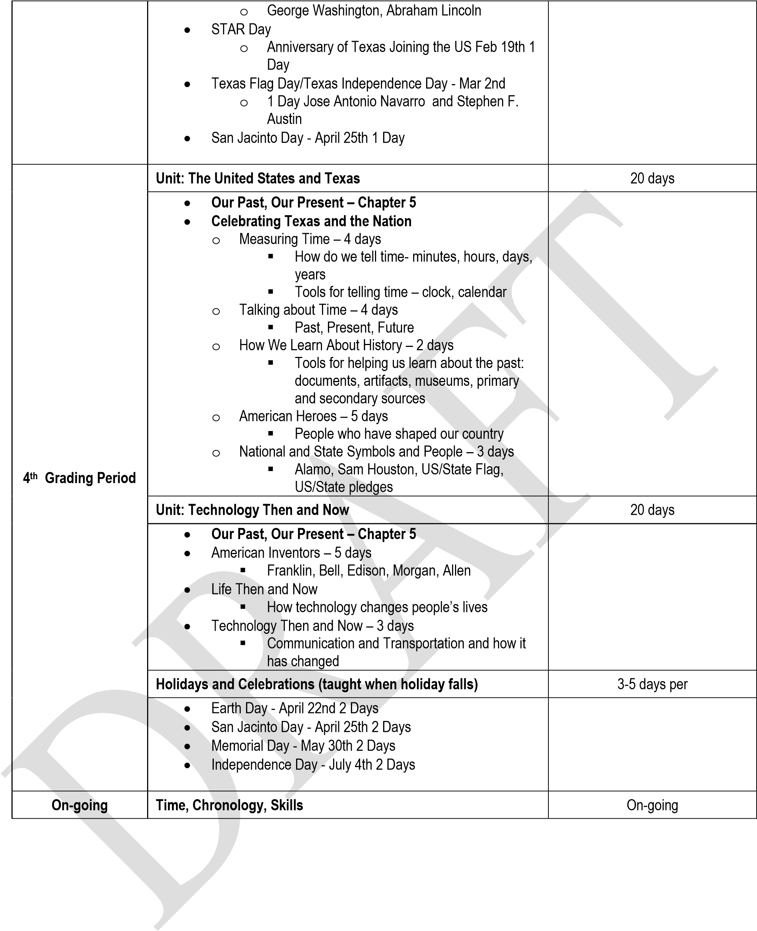

**First Grade ELAR At A Glance**

|  |  |  |  |
| --- | --- | --- | --- |
| **Grading Periods** | **Unit Name** | **Days** | **Dates** |
| Grading Period 1 | **Reading Workshop** |  |  |
| Unit 1: Launching Reading Workshop | 14 | 8/22-9/9 |
| Unit 2: Strategies and Schema in Fiction | 24 | 9/12-10/14 |
| Integrated Word Study: 1st 9 Weeks | 38 | 8/22-10/14 |
| **Writing Workshop** |  |  |
| Unit 1: Launching Writing Workshop | 14 | 8/22-9/9 |
| Unit 2: Personal Narrative | 24 | 9/12-10/14 |
| Grading Period 2 | **Reading Workshop** |  |  |
| Unit 3: Strategies and Schema in Expository | 19 | 10/18-11/11 |
| Unit 4: Building Stamina in Harder Texts | 20 | 11/14-12/16 |
| Integrated Word Study: 2nd 9 Weeks | 39 | 10/18-12/16 |
| **Writing Workshop** |  |  |
| Unit 3: All About | 19 | 10/18-11/11 |
| Unit 4: Small Moments | 20 | 11/14-12/16 |
| Grading Period 3 | **Reading Workshop** |  |  |
| Unit: 5: Describing and Inferring Character Behavior | 28 | 1/3-2/10 |
| Unit 6: Differentiating Fiction and Nonfiction | 19 | 2/13-3/10 |
| Integrated Word Study: 3rd 9 Weeks | 47 | 1/3-3/10 |
| **Writing Workshop** |  |  |
| Unit 5: Writing for an Audience | 28 | 1/3-2/10 |
| Unit 6: Writing for Different Purposes | 19 | 2/13-3/10 |

**First Grade ELA At a Glance**

|  |  |  |  |
| --- | --- | --- | --- |
| **Grading Periods** | **Unit Name** | **Days** | **Dates** |
| Grading Period 4 | **Reading Workshop** |  |  |
| Unit 7: Reading Research | 29 | 3/20-4/28 |
| Unit 8: Understanding Poetry | 23 | 5/1-6/1 |
| Integrated Word Study: 4th 9 Weeks | 52 | 3/20-6/1 |
| **Writing Workshop** |  |  |
| Unit 7: Research | 29 | 3/20-4/28 |
| Unit 8: Poetry | 23 | 5/1-6/1 |

**First Grade ELAR At A Glance**

|  |  |  |  |
| --- | --- | --- | --- |
| **Grading Periods** | **Unit Name** | **Days** | **Dates** |
| Grading Period 1 | **Reading Workshop** |  |  |
| Unit 1: Launching Reading Workshop | 14 | 8/22-9/9 |
| Unit 2: Strategies and Schema in Fiction | 24 | 9/12-10/14 |
| Integrated Word Study: 1st 9 Weeks | 38 | 8/22-10/14 |
| **Writing Workshop** |  |  |
| Unit 1: Launching Writing Workshop | 14 | 8/22-9/9 |
| Unit 2: Personal Narrative | 24 | 9/12-10/14 |
| Grading Period 2 | **Reading Workshop** |  |  |
| Unit 3: Strategies and Schema in Expository | 19 | 10/18-11/11 |
| Unit 4: Building Stamina in Harder Texts | 20 | 11/14-12/16 |
| Integrated Word Study: 2nd 9 Weeks | 39 | 10/18-12/16 |
| **Writing Workshop** |  |  |
| Unit 3: All About | 19 | 10/18-11/11 |
| Unit 4: Small Moments | 20 | 11/14-12/16 |
| Grading Period 3 | **Reading Workshop** |  |  |
| Unit: 5: Describing and Inferring Character Behavior | 28 | 1/3-2/10 |
| Unit 6: Differentiating Fiction and Nonfiction | 19 | 2/13-3/10 |
| Integrated Word Study: 3rd 9 Weeks | 47 | 1/3-3/10 |
| **Writing Workshop** |  |  |
| Unit 5: Writing for an Audience | 28 | 1/3-2/10 |
| Unit 6: Writing for Different Purposes | 19 | 2/13-3/10 |

**First Grade ELA At a Glance**

|  |  |  |  |
| --- | --- | --- | --- |
| **Grading Periods** | **Unit Name** | **Days** | **Dates** |
| Grading Period 4 | **Reading Workshop** |  |  |
| Unit 7: Reading Research | 29 | 3/20-4/28 |
| Unit 8: Understanding Poetry | 23 | 5/1-6/1 |
| Integrated Word Study: 4th 9 Weeks | 52 | 3/20-6/1 |
| **Writing Workshop** |  |  |
| Unit 7: Research | 29 | 3/20-4/28 |
| Unit 8: Poetry | 23 | 5/1-6/1 |